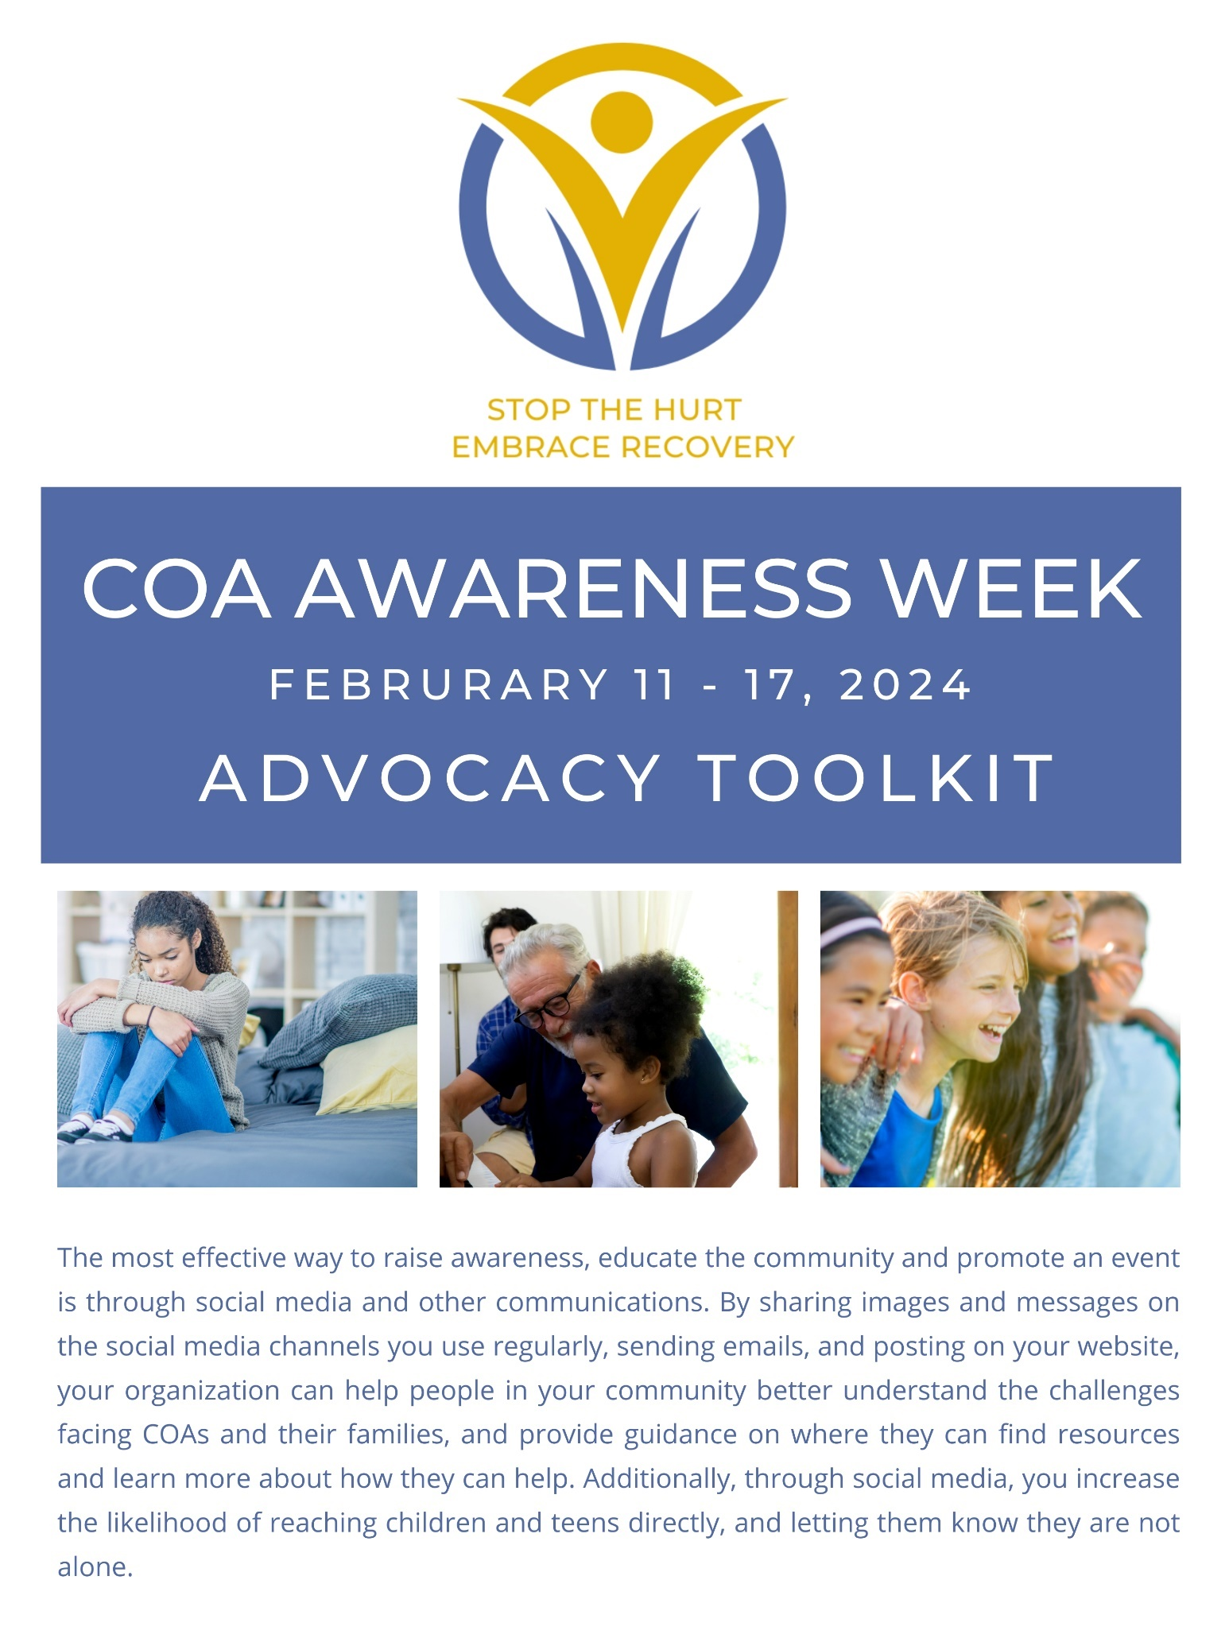
SOCIAL MEDIA
One of the easiest and quickest ways to reach others in the community is through social media. NACoA will be very active during COA Awareness Week. Please visit our social media channels often for posting ideas, or to share one of ours on your page. NACoA’s platforms: Facebook, Twitter, LinkedIn, Instagram.

On the following pages, you’ll find campaign-themed images and sample social media posts to help plan your own postings during the week. Right click on any of these images to save them and use!

SOCIAL MEDIA PROFILE PICTURE
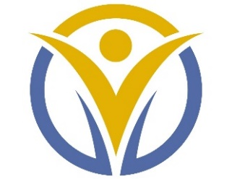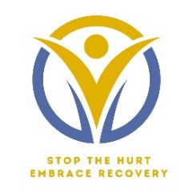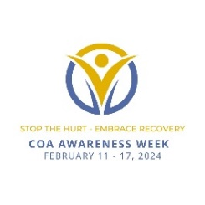

SOCIAL MEDIA POST IMAGES
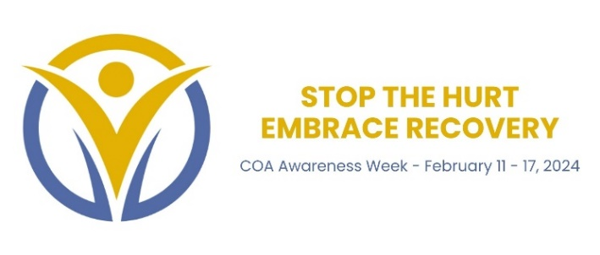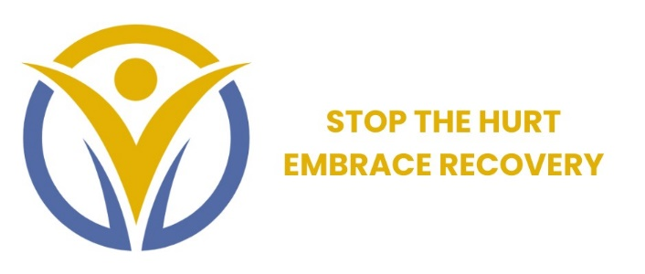
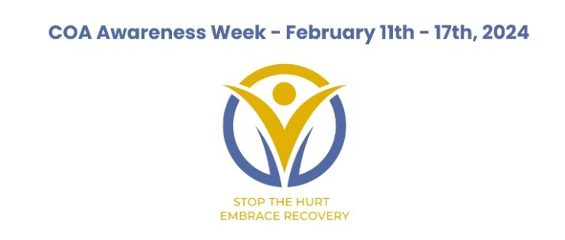
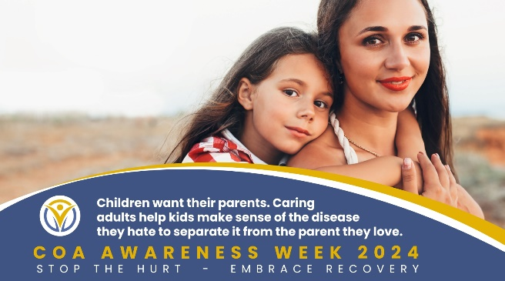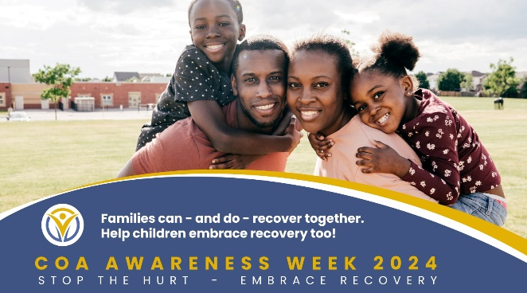

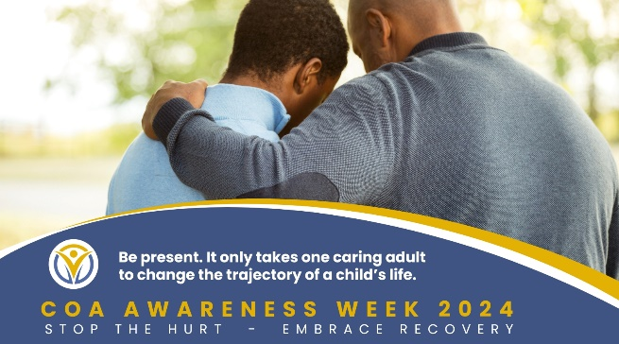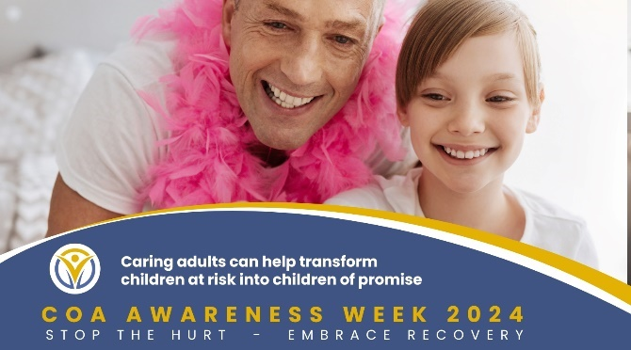

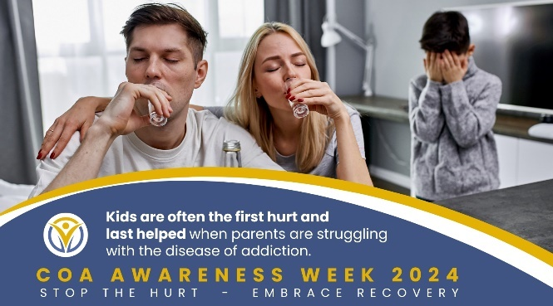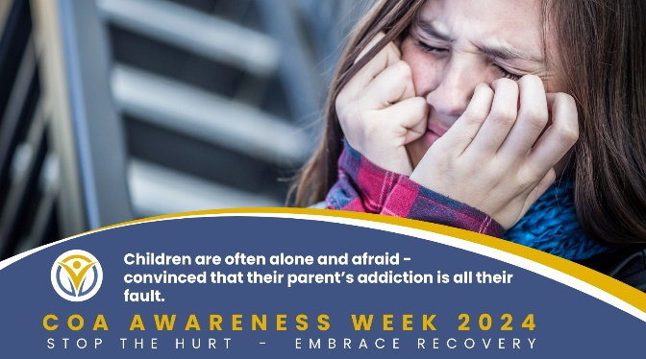

SAMPLE SOCIAL MEDIA POSTS
- #COAAwarenessWeek2024 is coming! Join us February 11-17th and raise awareness about children of addiction. Learn more https://nacoa.org/coa-awareness-week/ #COAWeek2024 #StoptheHurtEmbraceRecovery
- Together let’s help children impacted by addiction in the family. #COAWeek2024 #StoptheHurtEmbraceRecovery #CaringAdult #Teachers #SchoolPsychologists #Pediatricians #YouthMinisters #TreatmentCourt #YouthDeflectionSrvs Learn more https://nacoa.org/coa-awareness-week/
- Whether #alcohol, #opioids, or other substances, the pain and anguish for children living with addiction is the same. BUT IT DOESN’T HAVE TO BE THAT WAY! Learn more during #COAWeek2024 about how #caringadults can help. #COAs #StoptheHurtEmbraceRecovery https://nacoa.org
- Kids and teens can heal from the impact of parental addiction with proper support. It is critical to provide the support that can help children now! #COAAwarenessWeek2024 #StoptheHurtEmbraceRecovery https://nacoa.org
- Kids and teens begin to heal when they learn that #parentaladdiction isn’t their fault. #COAWeek2024 #StoptheHurtEmbraceRecovery https://nacoa.org
- Help kids and teens at risk become children of promise! #COAWeek2024 #StoptheHurtEmbraceRecovery https://nacoa.org/coa-awareness-week/
- Kids & #teens impacted by #parentaladdiction begin to heal when #caringadults know how to help. #COAWeek2024 #StoptheHurtEmbraceRecovery https://nacoa.org/coa-awareness-week/
- It only takes one #caringadult to change the trajectory of a child's life. Help make the difference in the lives of kids and teens to last a lifetime #COAWeek2024 https://nacoa.org/coa-awareness-week/

SAMPLE NEWSLETTER INCLUSION
When caring adults are safe and available for children impacted by the disease of familial addiction, they can help stop the pain and isolation and help children embrace recovery. COA Awareness Week breaks the silence that engulfs and traps kids and teens living with parental addiction and offers the chance for children at risk to become children of promise. Join us throughout this week to help make a difference that can last a lifetime.

SAMPLE EMAIL
1 in 4 kids and teens live in families impacted by parental addiction. They are so often the first hurt and last helped, yet the impact of living in a household with addiction can be lifelong.

Children Impacted by a parent who misuses substance are:
- At risk of lifelong negative mental and physical health consequences
- 3x more likely to be physically, emotionally, or sexually abused
- 4x more likely to be emotionally or physically neglected, with higher rates in rural populations
- More likely to be involved with child welfare
- More likely to lack self-awareness
- More likely to experience anxiety, depression, confusion, and anger
- More likely to experience unexcused absences and drop out of school
- More likely to have difficulty with direct communication
- Less likely to set healthy boundaries within relationships

These children are desperate for the support and understanding that can promote healing, help them embrace recovery, and continue to live healthier lives.

COA Awareness Week honors the struggle of children dealing with the disease of addiction in their families and empowers caring adults who want to help them. Together, we can make a difference to last a lifetime!

ADDITIONAL RESOURCES
Titles are linked to the documents. Link to them in your communications, or download, save, and use!

COA Awareness Week 2024 Flyer

COA Awareness Week Speaker Series Flyer

Why COA Awareness Week 2024

2024 COA Awareness Week Suggested Activities

Impacted of Alcohol/Opioid Use Disorder on Children Infographic

In addition, NACoA will be providing new resources during COA Awareness Week to complement advocacy efforts.

PROCLAMATIONS
A proclamation is a public or official announcement, especially one dealing with a matter of great importance. It is a written or printed document issued by a superior government executive, such as the president, governor or mayor, which sets out such a declaration by the government. It can issue policy, such as the Emancipation Proclamation. Proclamations are also used ceremonially, as an official announcement that publicly recognizes an initiative, a special event or occasion. A proclamation is a great way to build credibility for your issue, raise awareness and promote it.

Local Proclamations

Who
Contact Public Officials: Governors, Senators/Representatives, state legislator, County/City Council Members/Mayors

When
It is best to contact public officials at least one month in advance. Take into account the time of year. With summer schedules, consider contacting three months in advance of Recovery Month .

How
Check the website of the office which often outlines the procedure you will need to follow. If you prefer, write a letter or send an email to initiate correspondence with an official’s communications office, and follow up with a phone call.
It is good to include an explanation for the critical need to observe the campaign. When possible, detail scheduled local activities, and discuss the importance of the office’s support for this “annual event.” Explain that it’s a simple way for the government to recognize the impact on the community. The office typically will confirm and communicate its decision.
If granted, publicize as much as you can. Consider creating a ceremony to receive the proclamation. If you are denied a proclamation, always write a letter of gratitude for consideration.

Set goals during the upcoming year to have influential persons in your area prepare letters of support for a proclamation for you to submit with next year’s request. These types of letters can communicate the level of awareness and concern in your area, which can pique an official’s interest.

Presidential Proclamation
Presidents “define” situations or conditions on situations that become legal or economic truth or can be policy-based with situations that have a substantial impact on economic and domestic policy. In recent years, more proclamations have been issued to spotlight important awareness campaigns. In 2023, President Biden issued 183 proclamations. Typically, it is national organizations who spearhead these efforts.
Find a sample of a local proclamation here, provided by Maureen McGlame, RFK Community Alliance – COASA, a tireless champion for children in Boston who secures a proclamation every year for COA Awareness Week.

SAMHSA provides some additional tips for proclamations here>>

Guidelines and Disclaimer
COA Awareness Week graphics may be used for educational and informational purposes in relation to the advocacy week, and information found on Nacoa.org. Use of COA Week Awareness images does not indicate any form of endorsement or approval from NACoA.

