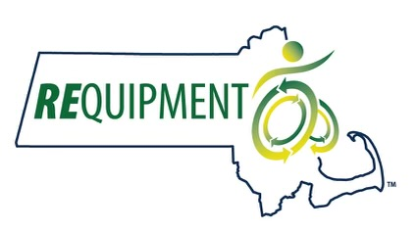Jennifer Baker Memorial Scholarship Application
Thank you for your interest in REquipment, Inc.’s Jennifer Baker Scholarship.
The scholarship provides the successful candidate with $1,000 in support of their education. Students from Massachusetts or Connecticut are eligible who are enrolled in (or accepted to) a course of study related to the provision of assistive technology (AT) or durable medical equipment (DME).
Eligible courses of study include physical therapy, occupational therapy, rehabilitation engineering, adaptive technology, special education, and speech/language pathology.
The ideal candidate will also demonstrate a strong interest in AT and DME reuse.
To apply, please submit a Word doc formatted to provide the following information and responses. [NOTE: applications that fail to follow this format will be discarded.]
- Name of applicant
- Home address
- Email address
- Phone number
- Name of school and program.*
- Type of degree/certification you are pursuing.
- What your plans are for the $1,000 scholarship. (One sentence.)
- Why should you be our next Jennifer Baker Scholar? (500 words.)
Tell us why you have chosen your field of study, about any experience you have with AT and/or DME making a difference, how you developed your interest in AT/DME reuse, and what you see as the role of reuse in the provision of AT/DME.

*Please attach proof of acceptance or attendance, such as a current transcript or acceptance letter.

Applications should be emailed to info@dmereuse.org with “Scholarship Application” in the subject line. The deadline for the 2024-25 academic year is April 1st, 2024. Notifications will be made by June 1st. The awardee must agree to have their photo and a brief bio published for promotional purposes.
Thank you, and good luck!

